Tips for Communicating with People with Hearing Loss
When audio is poor emphasize the visual.
Practice special speaking skills.

SET YOUR STAGE
- Get attention first.
- Avoid noisy backgrounds.
- Face audience directly.
- Spotlight your face, no backlighting.
- Ask how you can facilitate communication.

PROJECT YOUR COMMUNICATION
- Don’t shout.
- Speak clearly, at a moderate pace.
- Re–phrase if you are not understood.
- Use facial expressions, gestures.
- Give clues when changing subjects.
- Don’t hide your mouth, chew food, gum, or smoke while talking.

ESTABLISH EMPATHY WITH AUDIENCE
- Offer respect to help build confidence.
- Be patient if response seems slow.
- Stay positive and relaxed.
- Talk to a hard of hearing person, not about him/her.
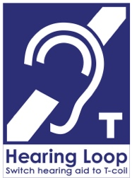

Symbol of Hearing Access

Hearing Loop

Tips for Communicating with People with Hearing Loss
When audio is poor emphasize the visual.
Practice special speaking skills.

SET YOUR STAGE
- Get attention first.
- Avoid noisy backgrounds.
- Face audience directly.
- Spotlight your face, no backlighting.
- Ask how you can facilitate communication.

PROJECT YOUR COMMUNICATION
- Don’t shout.
- Speak clearly, at a moderate pace.
- Re–phrase if you are not understood.
- Use facial expressions, gestures.
- Give clues when changing subjects.
- Don’t hide your mouth, chew food, gum, or smoke while talking.

ESTABLISH EMPATHY WITH AUDIENCE
- Offer respect to help build confidence.
- Be patient if response seems slow.
- Stay positive and relaxed.
- Talk to a hard of hearing person, not about him/her.
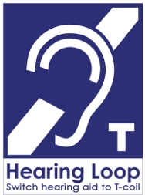

Symbol of Hearing Access
Hearing Loop

Tips for Communicating with People with Hearing Loss
When audio is poor emphasize the visual.
Practice special speaking skills.

SET YOUR STAGE
- Get attention first.
- Avoid noisy backgrounds.
- Face audience directly.
- Spotlight your face, no backlighting.
- Ask how you can facilitate communication.

PROJECT YOUR COMMUNICATION
- Don’t shout.
- Speak clearly, at a moderate pace.
- Re–phrase if you are not understood.
- Use facial expressions, gestures.
- Give clues when changing subjects.
- Don’t hide your mouth, chew food, gum, or smoke while talking.

ESTABLISH EMPATHY WITH AUDIENCE
- Offer respect to help build confidence.
- Be patient if response seems slow.
- Stay positive and relaxed.
- Talk to a hard of hearing person, not about him/her.

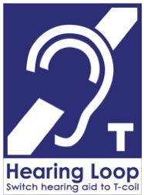

Symbol of Hearing Access
Hearing Loop

1,400,000 Washingtonians

Mothers, fathers, brothers, sisters,

children, friends, colleagues

Learn how to live well
with hearing loss

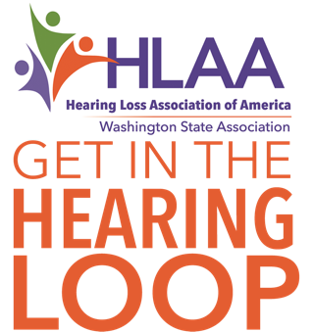

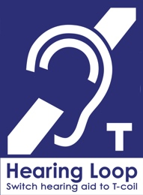

info@hearingloss-wa.org
www.hearingloss-wa.org

1,400,000 Washingtonians

Mothers, fathers, brothers, sisters,

children, friends, colleagues

Learn how to live well
with hearing loss

info@hearingloss-wa.org
www.hearingloss-wa.org

1,400,000 Washingtonians

Mothers, fathers, brothers, sisters,

children, friends, colleagues

Learn how to live well
with hearing loss

info@hearingloss-wa.org
www.hearingloss-wa.org

