Phone: 425-452-4471; 452-425-4072

Date: April 4, 2016

To: Mayor Stokes and City Councilmembers

From: Jennifer Mechem, ADA/Title VI Administrator, Diversity Advantage Team
Shannon Horst, Facilities Planning Coordinator, Civic Services

Subject: Hearing Loops in Council Chambers, Council Conference Room, and Bellevue Youth Theatre

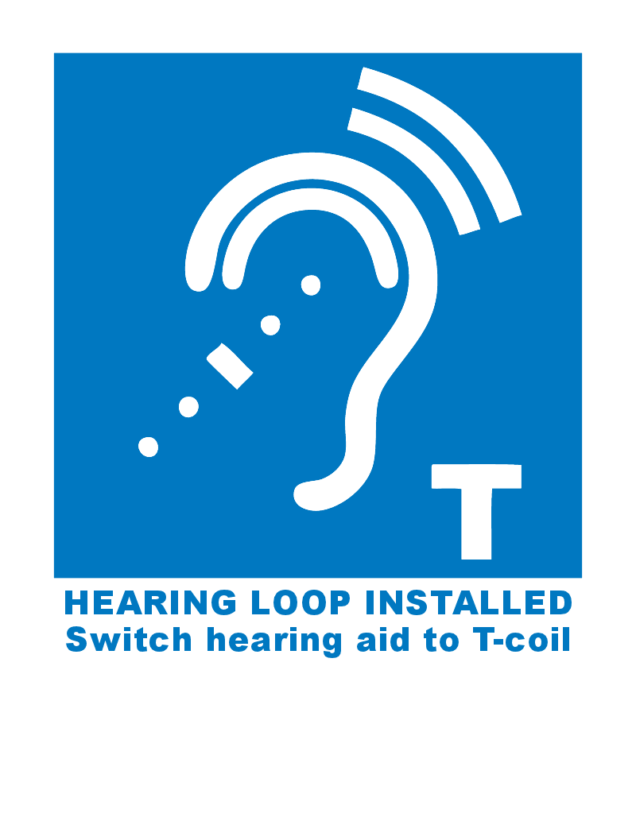
Overview
The City of Bellevue has installed state-of-the-art hearing loop systems in the City Hall Council Chambers, Council Conference Room, and Bellevue Youth Theatre to better serve the public and to reaffirm its commitment to the Americans with Disabilities Act (ADA).

Installation and activation of all three systems was completed in February 2016. Contractor HearingLoopNW designed an innovative phased-array system that minimizes dead spots and ensures consistent quality of sound. Staff worked closely with community members, the Hearing Loss Association of America, and Let’s Loop Seattle to test the systems.

Bellevue Youth Theatre plans an evening reception in April (date to be determined) to celebrate the hearing loop system. Council is invited.

Background
As part of its ADA commitment to effective communication for people with hearing loss, Council allocated Capital Improvement Project (CIP) Plan funding in 2015-16 to replace the old assistive listening systems with new hearing loop systems that provide greater functionality and ease of use for people with a wide range of hearing impairments.

These systems provide greater clarity of sound and increased amplification to enable people with hearing loss to hear and participate in events in these locations. A hearing loop is a permanently installed wire in the flooring that broadcasts a signal that can be picked up by any hearing aid or cochlear implant with a T-coil. A hearing loop is the most effective and easy-to-use system for the vast majority of individuals with hearing loss, as it delivers sound directly to the ear through the user’s own hearing device optimized for his or her hearing loss. Receivers and headsets are also available so anyone can use the system to hear better without a hearing aid.

The same loop technology can be used at service counters and other locations with transient customers. Counter loops have been installed at the ticket windows and concession window at the Bellevue Youth Theatre to enable customers to more easily communicate with staff.

Hearing loop systems are common throughout Western Europe, particularly in Britain and Scandinavian countries where they are nearly universal in theatres, houses of worship, and ticket windows.

A hearing loop was also installed in City Hall Room 1E-108, which can be used separately or together with the system in Room 1E-113, the Council Conference Room. Additional equipment and testing is required before this room can be activated; completion is anticipated in mid-2016.

The hearing loop systems replaced old FM assistive listening systems that required users to check out a receiver and headset. Those systems are still in good working order and will be retrofitted to serve as portable systems for spaces that cannot be looped, such as the wheeled podium used for events in the Concourse and other City Hall locations, and the outdoor amphitheater at the Bellevue Youth Theatre.

The next phase of hearing loop and assistive listening system installation will take place in 2017, pending budget approval. Bellevue Botanical Garden, North Bellevue Community Center, and Highland Community Center have been identified as the highest priority locations. As part of the public comment and review process for the City’s draft ADA Self-Evaluation and Transition Plan, the City is seeking community input on other City facilities and activities to include in the next phase.

Conclusion
Please speak clearly and directly into the microphones to ensure that everyone can hear you. As with any audio system, the quality of the sound coming out through the hearing loop depends on the quality of sound going in.

Please note the new signs indicating the hearing loop system.

