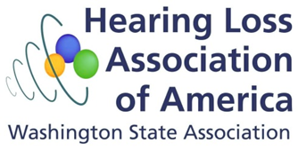
P R E S S R E L E A S E
October 25, 2013
Contact: Cheri Perazzoli, Let’s Loop Seattle/Hearing Loss Association of Washington
425-785-4904
loopseattle@gmail.com
KING COUNTY LIBRARY STEPS INTO THE LOOP
Extending a hand—and technology—to its patrons with hearing loss, the King County Library System announced the availability of its meeting room number 1 at the Bellevue branch as one of the first in the county to be equipped with a hearing loop.
“A hearing loop can literally be a life-changing experience for someone with hearing loss,” said Cheri Perazzoli, who heads Let’s Loop Seattle, an organization dedicated to making Seattle the most-accessible city in the country. “They don’t need to ask for a device, remember to bring equipment, or struggle with feeling embarrassed about admitting their hearing loss.”
A hearing loop is a simple copper coil installed around the perimeter of a room or a space, like a counter. The loop wirelessly sends the signal from a PA directly to a hearing aid user’s hearing aid or cochlear implant. The result: strikingly improved clarity and understanding. Hearing aids don’t restore normal hearing the way glasses restore vision, so many hearing aid users still struggle to hear in acoustically different environments, such as large spaces, airports, or places with background noise. Because hearing loss is often called the “invisible disability,” few people are aware of the challenges people with hearing loss—both treated and untreated—face every day.
While technically not a new technology, hearing loops are growing in popularity in the U.S. and Europe as simple, cost-effective ways to create accessible environments for customers and employees. Over 48 million Americans face some degree of hearing loss daily, including growing numbers of young people and veterans.
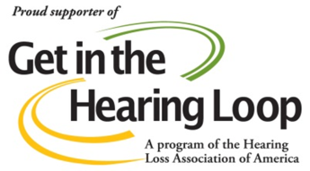
Organizations such as Let’s Loop Seattle are part of a national effort to install hearing loops in public places to address this growing need for public venues that are accessible to everyone, regardless of their ability to hear. As part of Universal Design (UD), hearing loops are among the most discreet, cost-effective, and low-maintenance best practices for disability accommodation.
Patrons and the general public can reserve the room at no charge. To reserve the room, visit http://www.kcls.org/meetingrooms/index.cfm.
The King County Library System offers many other services for individuals with disabilities, including the Xerox Reading Edge, magnification equipment, MAGic and JAWS, and audio and e-books.
###
Let’s Loop Seattle is a public education and advocacy campaign launched by the Hearing Loss Association of Washington (HLA‐WA) in cooperation with the American Academy of Audiology (AAA) and the Hearing Loss Association of America (HLAA). Let’s Loop Seattle builds knowledge about hearing loop technology, provides information and resources to facilities and users, supports certified installations, and most importantly, strives to bring hearing loop technology to the Puget Sound area. For more information, contact Let’s Loop Seattle, www.loopseattle.org, or connect with Let’s Loop Seattle on Twitter (@LetsLoopSeattle) and Facebook (http://www.facebook.com/LoopSeattle).
The King County Library System’s mission is to provide free, open, and equal access to ideas and information to all members of the community. In 2012, the KCLS served 10.1 million visitors through its 48 community libraries. For more information on events, books, services, programs, and classes, visit www.kcls.org.

