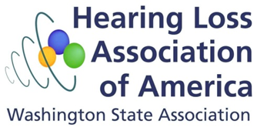
For immediate release
Contact: Cheri Perazzoli
cheripz@gmail.com
loopseattle@gmail.com
City of Bellevue Enhances Access for People with Hearing Loss

Bellevue, WA – The City of Bellevue has installed hearing loops in several locations to improve hearing access for people with hearing loss. Hearing loops are now installed in the Bellevue City Council Chambers, the Council Study Room, and the Bellevue Youth Theatre. The hearing loops will be inaugurated with a demonstration at a City Council meeting April 4, 2016, at 8 pm, and at a public reception at Bellevue Youth Theatre on April 16, 2016, at 6pm, before the 7 pm showing of Oklahoma!.

Hearing loops (also called induction loops, or simply loops) enable people with hearing aids and cochlear implants to connect directly to a venue’s sound system so that they can understand clearly. Loops are copper wires installed in the floor and walls of a venue or room. Loops transmit sound drawn from the venue’s public address system to telecoils found in most hearing aids and in all cochlear implants.

By switching to telecoil mode in their hearing aids or cochlear implants, many people with hearing loss can clearly hear and understand sound captured by venue microphones. Unlike the individual FM or infrared listening systems available in many venues, loops allow users to hear sound through their customized hearing aids or cochlear implants, making the loop a discreet and customized option. Looping amplifies the sound of the person speaking while minimizing background noise. People without telecoils in their hearing devices can use a hearing loop receiver and headphones to hear the sound transmitted through a loop.

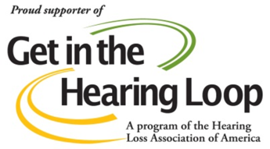
"Installing hearing loops at Bellevue facilities, like the council chambers, allows us to maximize participation in civic and cultural events," said Bellevue Councilmember Lynne Robinson, who jointly with then Bellevue mayor Claudia Balducci (now a King County Council member) advocated for installation of hearing loops. "Given our community's ongoing focus on connectivity, completion of this project is very exciting."

"We couldn't have done this without the support from City Council and the community. Installing hearing loops is just one part of our overall commitment to improving access for people with disabilities and promoting equity and inclusion as part of our Diversity Initiative," said Jennifer Mechem, the city's Americans with Disabilities Act (ADA) coordinator.

The Hearing Loss Association of Washington worked closely with the City of Bellevue to design and test the systems, and to get the support of City Council members for Capital Improvement Project funds to be allocated to install the loops. “Hearing loops are the equivalent of a wheelchair ramp or a curb cut,” said Cheri Perazzoli, Hearing Loss Association of Washington (HLAA-WA) trustee and founder of Let’s Loop Seattle, a program of the Hearing Loss Association of America. “People with hearing loss often find their hearing aids alone are ineffective in large venues. We’ve long needed this kind of infrastructure support to connect us to the community.”

Diana Thompson, an HLAA-WA member and advocate and vice chair of the Bellevue Network on Aging, stressed the need for accessible public places: “Many venues recognize the importance of meeting the needs of the deaf by providing sign language interpreters. However, most people with hearing loss do not know sign language. To meet the needs of people with hearing loss who are not deaf, we need technologies such as looping so we can all understand and participate fully in our communities.”

The same loop technology can be used at service counters and other locations with transient customers. Counter loops have been installed at the ticket windows and concession window at the Bellevue Youth Theatre to enable customers to more easily communicate with staff. Public contact staff have been trained on the assistive listening systems available for people attending City Hall and Bellevue Youth Theatre events, and new signage has been prominently placed. The hearing loops were installed by hearing loop specialist Spencer Norby of HearingLoopNW.

